**SINGLE STATUS / BACHELORHOOD CERTIFICATE AFFIDAVIT**

I **Your Name** , D/o. Mr. Father Name and Mrs.Mother Name , residing at XXXX Address on passport XXXXX Pincode - XXXXX , INDIA, do hereby solemnly affirm and state on oath as follows:

1. That I am a citizen of India.

2. That I am XX years old.

3. That I am of good health and good mental condition.

4. That I was born on **XX-XX-XXXX (TEN EIGHT NINETEEN NINETY-FIVE) at City, State.**

5. That I am a holder of valid Indian passport bearing **No. XXXX Passport Number**

issued at XXCity, XXCountry valid from **18/04/2022 to 17/04/2032.**

6. That I am **not married** and have **no spouse living** or **dead** anywhere in **India** or **abroad**.

7. That I am **eligible** to marry an Indian or person of any other nationality according to the law. I am **Single / Unmarried** **/ Bachelor** at present.

8. That my mother is Mrs. Mother Name, a holder of valid Indian Aadhaar Card with Aadhaar No. **XXXX XXXX XXXX**  issued at Kolkata, West Bengal, India.

9. That my father is Mr. Father Name, held a valid Indian Aadhaar Card with Aadhaar No. **XXXX XXX XXXX** issued at Kolkata, West Bengal, India.

10. That whatever stated hereinabove is correct to the best of my knowledge and understand that I am liable to be prosecuted, if this affidavit or any part of it is anyway found incorrect or false.

11. That my parents have no objection for me getting married to an Indian or person of any other nationality according to the law.

12. This affidavit is true, and it conceals nothing and no part of it is false.

**Place:** City, State, India.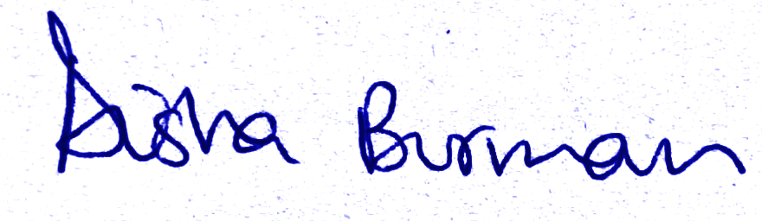

**Date:** 21/06/2024

**DEPONENT**

**Your Name**